

Volunteers’ Management System
Software Design Document

Spring 2010
Technical Challenge Project

By:
Apollo Group

Table of Contents

Content Page #

1 Introduction 3
1.1 Purpose 3
1.2 Scope 3
1.3 Overview 3
1.4 Reference Material 3
1.5 Definitions and Acronyms 3
2 System Architecture Overview 4
3 Structural Design 5
3.1 Presentation Layer 5
3.2 Data Layer 7
3.3 Web Service Layer 8
3.4 Business Layer 8
3.5 Database Design 11
4 Behavioral Design 12
4.1 Request time out 12
4.2 Automatic requesting 12
4.3 An example of use-case realization: Create Crisis 14
4.4 Automatic Update of Pages 14
4.5 Validating and Verifying Information 15
4.6 Volunteer’s Location 15
4.7 Volunteer Login time out 15
5 Human Interface Design 16
5.1 Overview of User Interface 16
5.2 Screen Images 16
5.2.1 Crisis Page 16
5.2.2 Incident Page 16
5.2.3 Request Page 17
5.2.4 Login Page 18
5.2.5 Manager Registration Page 19
5.2.6 Volunteer’s Registration Page 21
5.2.7 View Incident Page 21
5.2.8 Volunteer’s Report Page 22
5.3 Screen objects and Actions 23
6 Summary 24

Introduction

Purpose
This design description document covers the details of different layers and components previously given in the architectural description document. Since the implementation will be built upon this description, this document can be considered as a reference point for developers as well as other stakeholders.

Scope
Software Design Document contains the components, subsystems, class diagrams, detailed classes explanation, data structure and guidelines for human interface design.

Overview
The detailed explanation of the system design is divided into two as;
- Structural Design
- Behavioural Design

Structural design covers the static views of the system including class diagrams and data model while behavioural design explains the dynamic aspects of the system such as interaction between components, state changes and etc.

At the end, human interface design is given as a separate section.

Reference Material
- IEEE Std 1016™-2009, IEEE Recommended Practice for Software Design Descriptions, July 2009

Definitions and Acronyms
- Volunteers’ Management System – VMS
- Software Requirements Specification – SRS
- Crisis manager – the manager of the crisis of the humanistic organizations
- Volunteer – the user who will use the system except the crisis manager
- Request – the request created by the crisis manager about the help needed for resolving the incident
- Need list – the list of items needed for resolving the incident

System Architecture Overview
Proposed VMS architecture adopts a multi layered approach. To gain the maximum flexibility and maintainability, each specific unit is separated as layers. It also assures the cohesion and coupling rule of design. The layering structure of VMS can be seen below:

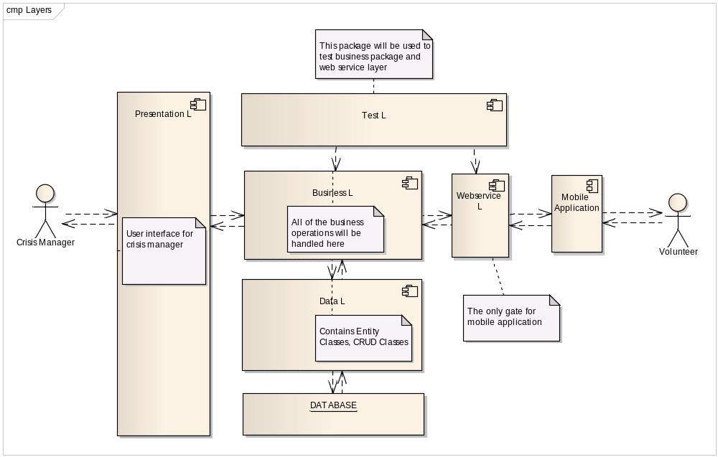
Figure 1: Layering Structure of VMS
Each layer has specific responsibilities.

Presentation Layer: Works as a medium that forwards inputs to the business logic. All web-based user interface components and controls will be created in this package. There are also some components which manage the sequence of showing the pages to the user and manage the flow of events on a particular page. They also provide needed data for page classes and user interface components.

Business Layer: Contains services which coordinate and handle the process of performing system functionality.

Data Layer: Contains entity classes and O/R mapping configurations. Responsible for persisting objects to the database and retrieving them from the database.

Web Service: Works as an interface to mobile devices. All clients and other services which need to use the encapsulated services inside business logic layer have to be incorporated through this interface.

Test Layer: A temporary layer to be used to test the web service and business layers.

Internal structures of the layers will be detailed in following sections.

Structural Design
Structural design of VMS includes static views of the system. Since VMS is following object oriented approach, class diagrams are the most important part of structural design. Apart from class diagrams, database design is also another part of structural design description.

In this section, the classes in the different layers will be presented first. Important attributes and methods will be given.

Then, database model of VMS system will be given.

Presentation Layer
Presentation layer represents the web interface which crisis manager will use. It has all the web pages, base classes of the pages and master pages. Sample relation between these items can be visualized as in Figure 2.

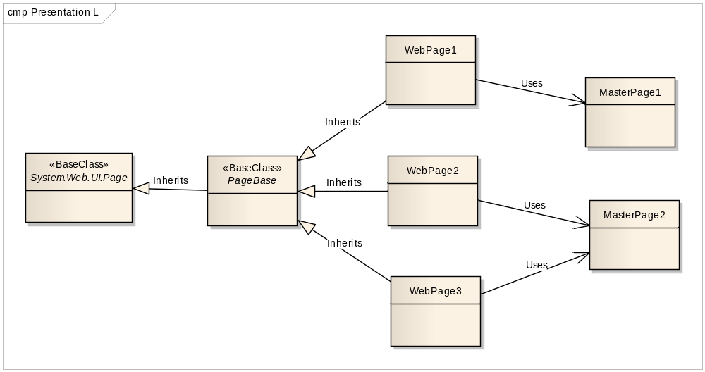
Figure 2: Relation between web pages, base classes and master pages
Although, the final list of pages and other items are not definite now, the most important ones are listed in the following table.

Item name | Item type | Role
PageBase | Base Class | Contains logic that is common to all web pages such as:  - authentication control  - logging  - utility methods for formatting
PageMaster | Master Page | Is a template for the pages. Defines the static regions and changeable regions of the page that uses it. Contains common javascript dependencies and scripts.
UCMap | User Control | Contains the map interface implementation. All of the javascript settings will be mapped to C# settings which means that it has similar attributes and settings to javascript settings required by Google Maps. All other pages that require Google Map will use this user control.
Main.aspx | Web Page | The main page that comes after login. Shows all of the crisis, and used to reach managerial tasks such as reports.
CrisisBoard.aspx | Web Page | The dash board that shows the important information of a crisis such as ongoing incidents, new incident reports and the map showing all of the incidents.
Crisis.aspx | Web Page | Used for creating and modifying the crisis
Incident.aspx | Web Page | Used for creating and modifying the incidents
Request.aspx | Web Page | Used for creating and modifying the request that belongs to an incident.
VolunteerInfo.aspx | Web Page | Used for viewing the volunteer information.
Alert.aspx | Web Page | Used for viewing and sending alerts to the volunteers.
Figure 3: Presentation layer items

Data Layer
Data layer of the architecture contains the entity classes and enumerations used in entity classes. The role of this layer is to centralize the data access logic. Following class diagram shows the items and relations in this layer.

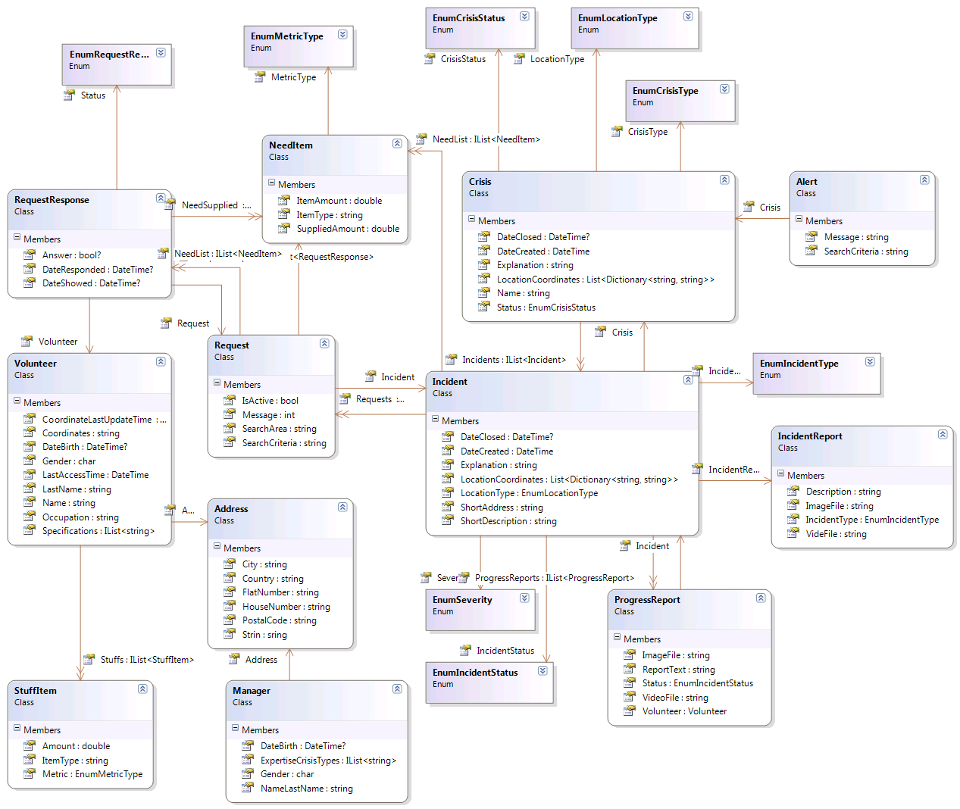
Figure 4: Class Diagram for Data Layer
Besides the visualized entity classes, there are also Entity Framework related classes which will not be mentioned here.

Web Service Layer
Web service layer functions as an interface to mobile application functionality. It contains a web service file (.asmx) and inside it, several methods needed by mobile application. However, the methods don’t contain any logic. All of the logic is contained in business layer and web service methods forward calls to business logic. This layer is also responsible to carry out communication between client and server.
The web methods are listed below:

Method Signature | Description
Volunteer Login(string username, string password, long crisisID) | Used for authentication of volunteers.
String CheckUpdate(long volunteerID) | Will be called periodically by mobile application to check any information update such as new request. A predefined string is returned indicating the data that is updated.
Request GetRequest(long requestID) | Used to retrieve the request content
Void RespondToRequest(long volunteerID, long requestID, IList<NeedItem> suppliedList) | Used to report the response for a request
Alert GetAlert(long volunteerID, long alertID) | Used to retrieve alert content
Void SetStuffList(long volunteerID, IList<StuffItem> stuffs) | Used to update the stuff list that volunteer has
Void ProgressReport(long volunteerID, long incidentID, string message, EnumIncidentStatus status, byte[] picture, byte[] video) | Used to report incident progress
Void IncidentReport(long volunteerID, string message, EnumIncidentStatus status, byte[] picture, byte[] video) | Used to report new incidents
Void SetVolunteerLocation( long volunteerID, string coordinates) | Updates the current location of volunteer
Table 1: The web service methods

Business Layer
Business layer is the one of the most important parts of VMS. All of the processing logic is contained here. Since this layer is based on the operations, all of the classes are using singleton design pattern allowing only one static instance of the class that is shared by all requests.

The operation classes and preliminary operations they serve are listed below.

Method Signature | Description
CrisisOperations Class
Crisis CreateCrisis(string name, string explanation, EnumCrisisType crisistype, EnumLocationType locationType,string formattedCoordinates) | Creates the crisis objects and saves to the database.
Crisis GetCrisis(long crisisID) | Retrieves and returns the specified crisis object
Crisis UpdateCrisis(long crisisID, string name, string explanation, EnumCrisisType crisisType, EnumLocationType locationType, string formattedCoordinates, EnumCrisisStatus status) | Updates the crisis and saves to the database
IncidentOperations Class
Incident CreateIncident(long crisisID, string desc, EnumLocationType locationType, IList<string> coordinates, string explanation, EnumIncidentSeverity severity, EnumIncidentType incidentType, IList<NeedItem> needlist, string shortAddress) | Creates a new incident and saves it to the database
Incident GetIncident(long incidentID) | Retrieves the specified incident and returns it
Incident UpdateIncident(long incidentID, string desc,string explanation, EnumLocationType locationType, IList<string> coordinates, EnumIncidentType incidentType, IList<NeedItem> needlist, string shortAddress, EnumIncidentStatus status) | Used to update incident information.
VolunteerOperations Class
Volunteer RegisterVolunteer( string nameLastName, char gender, Date? dateBirth, string occupation, string specification, string address, IList<StuffItem> stuffs) | Used to create new volunteers
Volunteer UpdateVolunteer( long volunteerID, string nameLastName, char gender, Date? dateBirth, string occupation, string specification, string address, IList<StuffItem> stuffs, string coordinates, DateTime locationLastUpdate) | Updates volunteer information
RequestOperations Class
Request CreateRequest(long incidentID, string message, string searchCriteria, IList<NeedItem> needlist, string searchArea) | Used to create new request
Request UpdateRequest(long requestID, string message, string searchCriteria, IList<NeedItem>, string searchArea, bool isActive) | Used to update the request object
RequestResponse SaveResponseToRequest( long requestID, long volunteerID, IList<NeedItem> suppliedNeeds) | Used to save the response of volunteer
Void AutomaticRequesting() | Triggered by automatic requesting thread to process automatic requesting logic.
Request GetRequest(long requestID) | Used to retrieve the request
Table 2: Business classes and their operations

Database Design
TBD

Behavioral Design
Behavioral design explains the critical and difficult behaviour of the system. This section contains sequence diagrams, which show the sequence of the communication of the classes for performing important functionality of the system. It explains the behavior of the system in different situations; the behavior of the system for the important functionality like automatic request sending, request time-out, information caching, data verification and validation, updating the web pages are explained in this section in detail.

Request time out
When the crisis manager creates and sends the request to the volunteers some of volunteers may not reply. The system will wait for 15 minutes and will send a new request to another volunteers. In this kind of cases the system will behave in this way. The system will retrieve from the database all requests and for each request the following will be done:
System will get the RequestResponce records for the particular request which is the list of volunteers to whom the request had been assigned and who didn’t relied to the request. That records also will contain the assigned date and time. If the request had been assigned to that volunteer more than 15 minutes ago, than the system will mark that answer as rejected and will update the RequestResponce records in database.
After that based on the request criteria and need list the system will search for the new volunteers and will create the records for that volunteers in RequestResponce table.
In case if volunteer has already rejected the request or has not answered within 15 minute, he will not be requested again.
This operation should be done every 5 minute.

Automatic requesting
“Automatic request sending” is a part of the functionality for the sending the requests to the volunteers. When the request is created and assigned to the volunteers the system will create the VolunteersList as it explained in the section 4.1.
The sequence diagram shows which steps are needed for the sending the request to the volunteers.

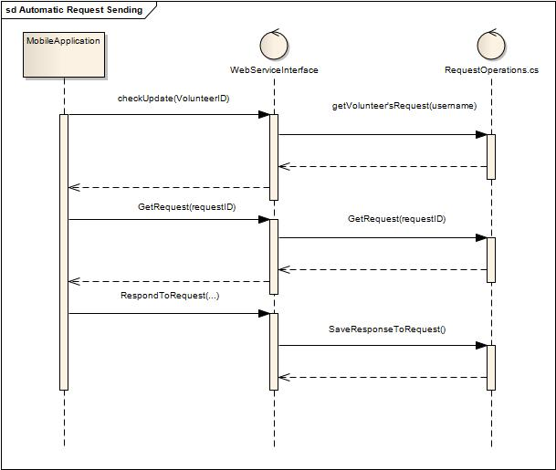

When the volunteer is logged in to the system by the mobile application and the list of requests is empty, the mobile application will check every 1 minute for the new request. checkUpdate() method checks from the web service for the new request for the volunteer. In case of assigned request to that volunteer, the web service will send the request to the mobile application. If volunteer choose the request, the mobile application will request the web service for all information of the request.
Web service get the request information using the GetRequest () method of the RequestOperations class. RequestOperations class gets the request information and returns it to the WebServiceInterface class. WebServiceInterface class return the full information about the request to the mobile application. In case if volunteer provide some or all the items from the needed item list, mobile application will send the answer to the web service by calling the method RespondToRequest() of the WebServiceInterface class. The SaveResponseToRequest() method will be called from the WebServiceInterface class, which will save the answer of the volunteer. The need item list will be recalculated and updated.

An example of use-case realization: Create Crisis
The sequence diagram for the Create Crisis use-case shows how the system should perform this use-case. This sequence diagram should be considered as the stereotype for the other use-cases.
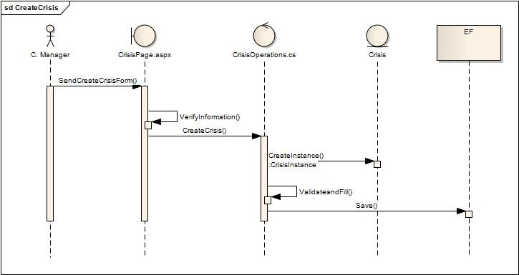

In this diagram the workflow begins from the manager. Manager have already filled the crisis information and pressed save button in the Crisis page. Using JavaScript and Ajax the information will be verified before sending it to the system. After verifying the crisis information the CreateCrisis method of the CrisisOperations class is called. This method validates the information, creates and initializes the instance of the Crisis class and saves it using Entity Framework.

Automatic Update of Pages
One of the important parts of the behaviour of the system is the refreshing the pages. When the data is changed in the database; the up-to-date information should be shown to the manager. The need item list, the volunteer’s answers, volunteer’s reports, volunteer’s incident progress reports are very important information and have to be updated on the web page immediately after updating in the database. These kinds of problems can be solved by the Ajax and JavaScript. Using Ajax and JavaScript only the part of the opened web page can be updated.
The following example can help to understand the purpose of using Ajax and JavaScript for updating the part of the opened web page and not whole the page.
The manager is logged in the system and viewing the incident information on View Incident page. At that time the volunteers can answer to the requests by accepting the request. In this case the list of accepted volunteers and need items list should be updated as soon as possible. To reach this goal and to be able to update the only accepted volunteers’ list and need item list, Ajax and JavaScript can be used instead of updating the whole page every second. Every second Ajax and JavaScript can check for the changes and in case of any change easily update the part of the web page.

Validating and Verifying Information
Before storing the information in the database it has to be validated and verified. In the client side of the web application the verification can be done for missing information, incorrect format, patterns, repeating names, etc. This kind of verification can be done using Ajax and JavaScript. In case when the information has not been verified, it should not be sent to the server. The user will get error message with the explanation of the error. Information about non-verified data will be highlighted by the red color.
The verification in the mobile application will be done directly in the mobile user interface. If the verification has failed, the information will not be sent to the web service. The user should be able to see the cause of the error.
All kinds of validation of information before storing in the database should be done on the server side, by the Business Logic Layer.

Volunteer’s Location
Mobile application will check the location of the volunteer after every one minute. If the location of volunteer has been changed, mobile application will send the new location to the web service, and then the system will update the new location of the volunteer.

Volunteer Login time out
Sometimes the connection between the mobile application and web service could be broken. To avoid of assigning the request to volunteers in this kind of situation, when the volunteer no longer is logged in, the system will check the last communication of the mobile application with the web service after every one minute. If the last communication of the mobile application with the web service is occurred more than five minutes before then the system will mark the volunteer as logged out.

Human Interface Design

Overview of User Interface
Crisis manager will use the web portal by his/her web browser to perform the needed operations. The volunteers will connect to the system via their mobile application. The volunteer registration will be done by the web portal using the web browser.
The developers should follow to the prototype of VMS system when designing the user interface. The designers of the user interface will use the screen shots as the main guide for designing the user interface for the web portal but improve it if it’s possible or if better solution is found. The mobile application’s interface should be designed using J2ME UI components.

Screen Images
It’s intuitive that some screens should carry out functionalities of the system detailed in SRS. In this section we will make a basic idea of what the system user interface will look like. But for the beginning let’s see which use-cases will be carried out in which screens and then the details of the screens will be shown in basic schemas.

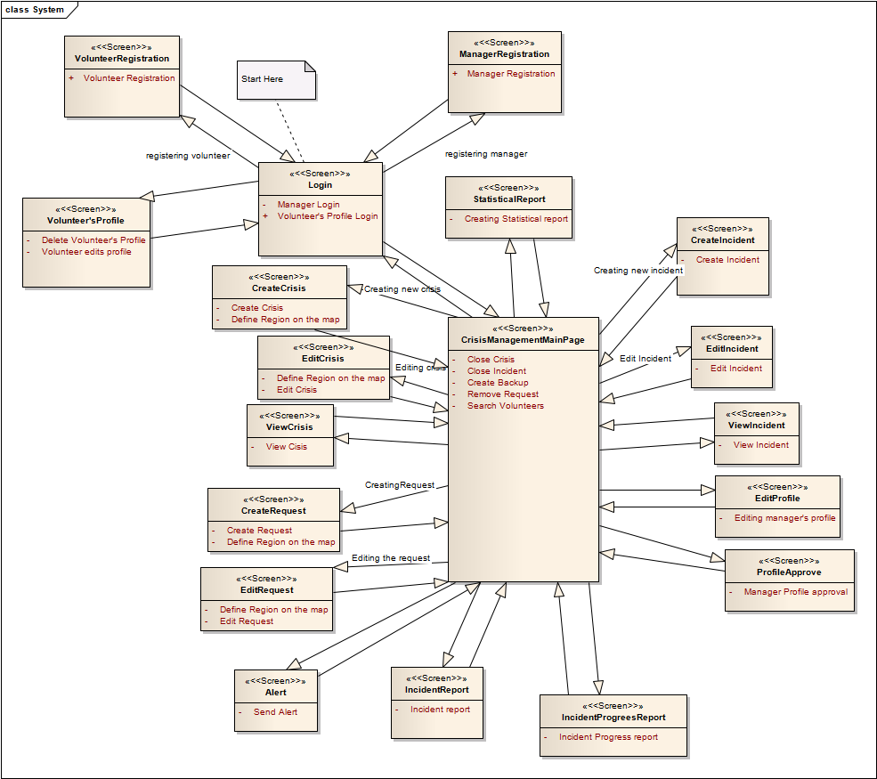

Crisis Page

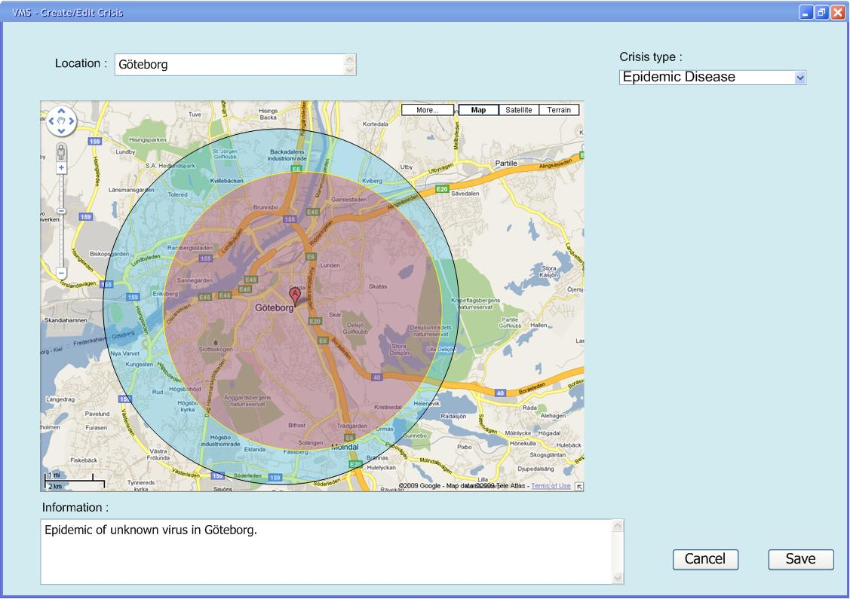

Use-cases | Description
Create crisis | Manager defines a new crisis in the system.
Edit crisis | Manager modifies any information of a previously created crisis that is active.

Incident Page

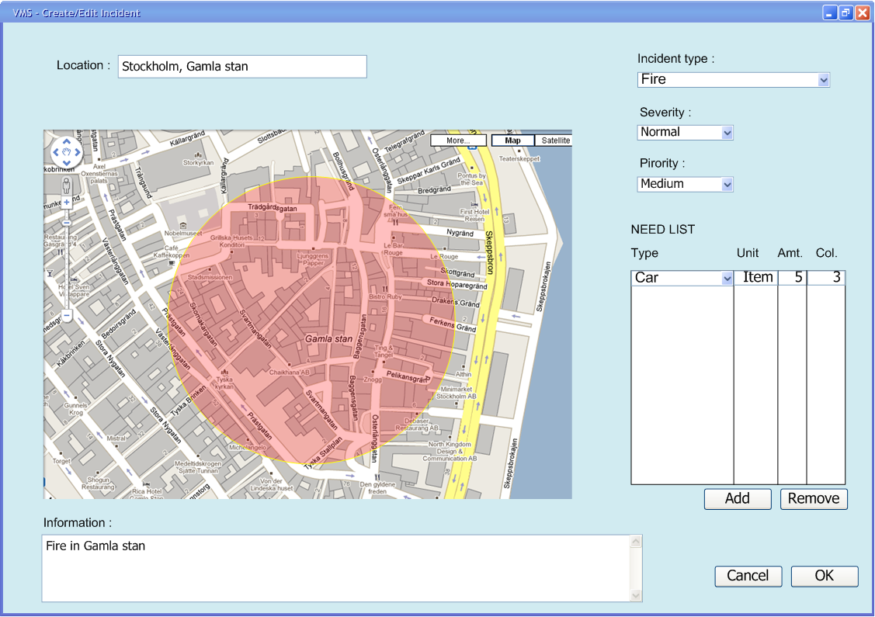

Use-cases | Description
Create incident | Manager defines a new incident in the system including resources needed for that incident
Edit incident | Manager edits the information of an active incident.

Request Page

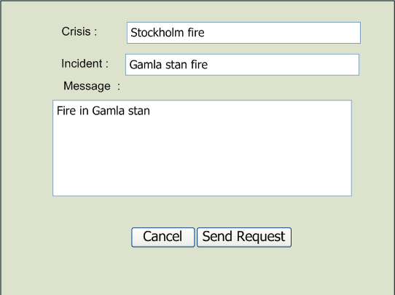

Use-cases | Description
Create request | Manager creates and sends a request related to an active incident.
Edit request | Manager will change the content of a request of an incident

Login Page

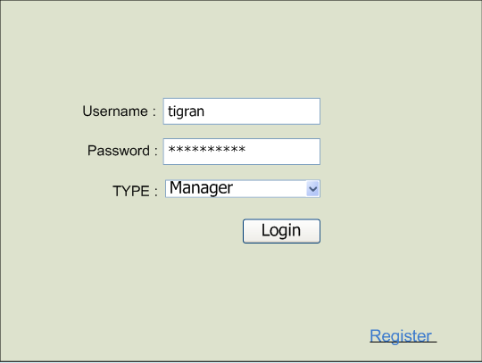

Use-cases | Description
Manager login | Manager logins to the system
Volunteer profile login | Volunteer logins to his/her profile through web portal

Manager Registration Page

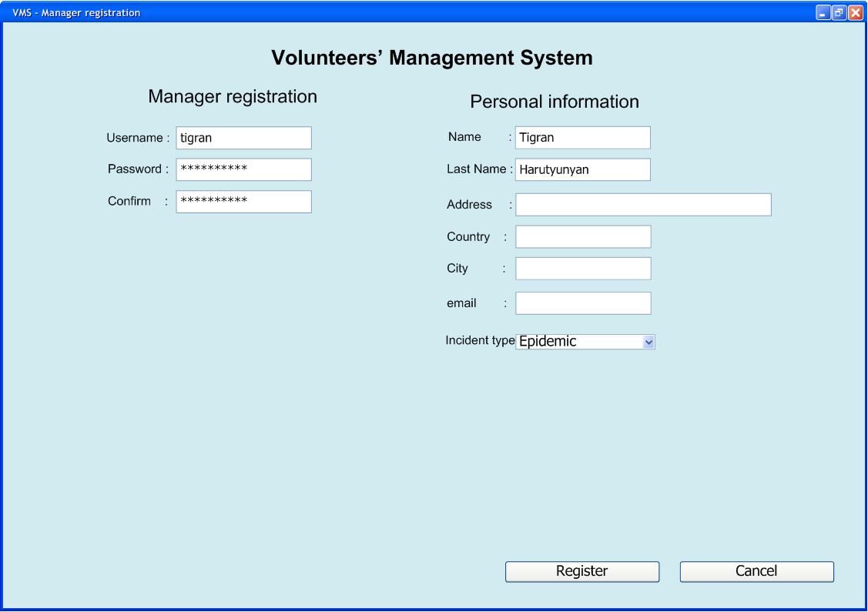

Use-cases | Description
Manager registration | Registers a manager in the system

Volunteer’s Registration Page

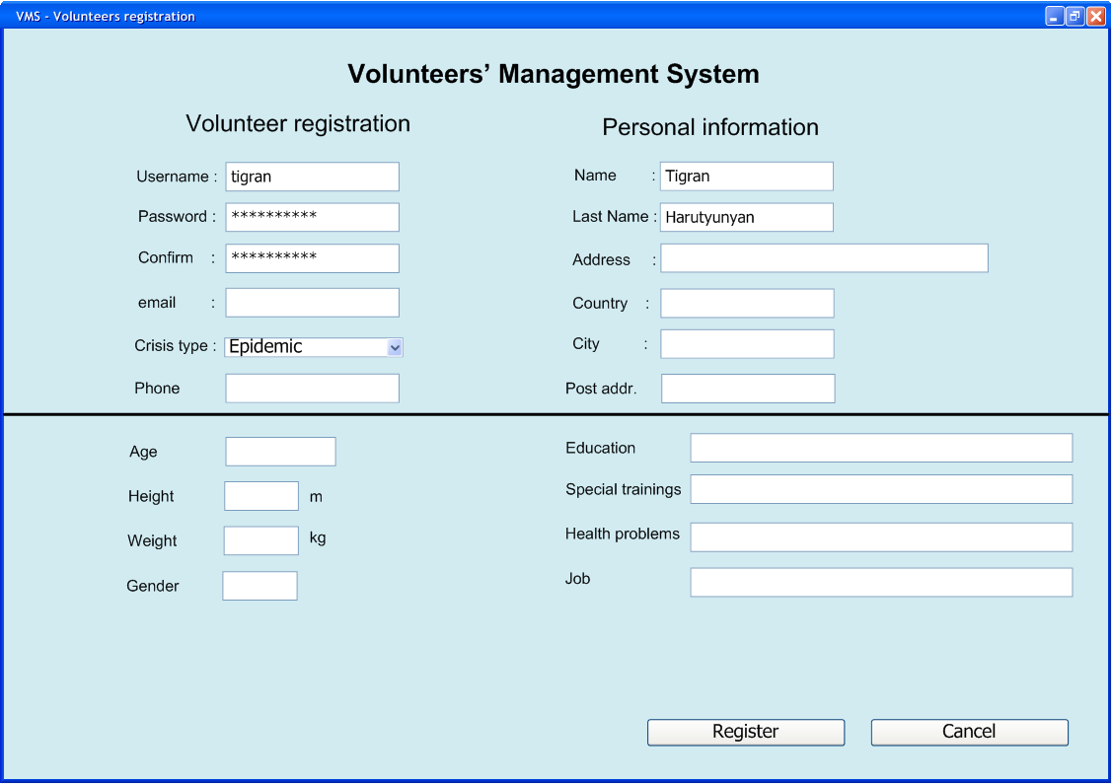

Use-cases | Description
Volunteer registration | Manager views the incident details.

View Incident Page

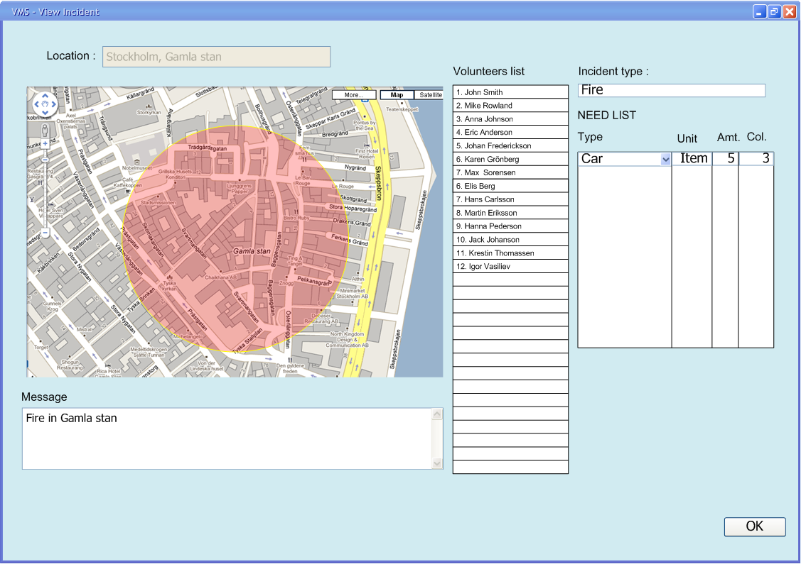

Use-cases | Description
View incident information | Manager views the incident details

Volunteer’s Report Page

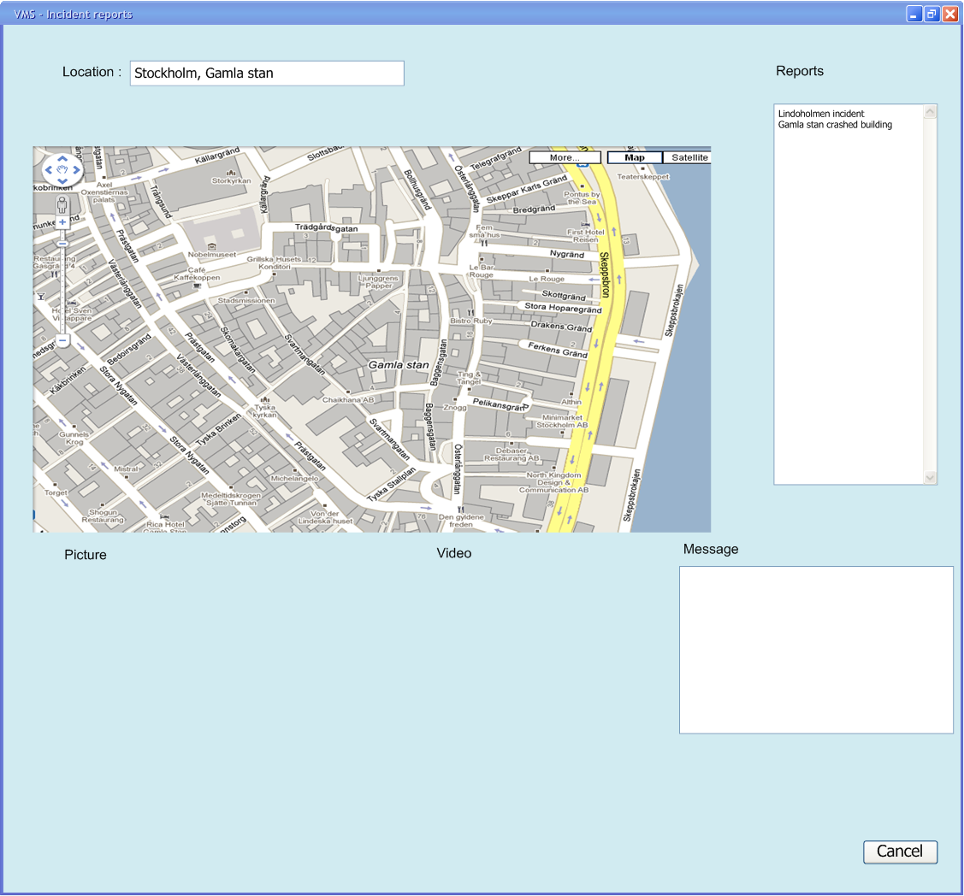

Use-cases | Description
View volunteers’ incident report | Manager gets the reports from volunteers that will be used for creating or updating incidents

Summary

Revision History

Name | Date | Reason for Changes | Version
Tigran Harutyunyan | 15 Mar 10 | Created sections 1, 4 and 5 | 0.1
Item 2 | 09 Oct 09 | Some text | 2.0
Item 3 | 16 Oct 09 | Some text | 2.1

